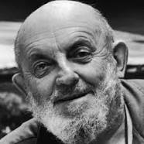
Ansel Easton Adams was an American photographer and environmentalist. His black-and-white landscape photographs of the American West, especially Yosemite National Park, have been widely reproduced on calendars, posters, and books.

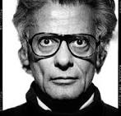
Richard Avedon was an American fashion and portrait photographer. An obituary published in The New York Times said that "his fashion and portrait photographs helped define America's image of style, beauty and culture for the last half-century

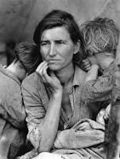
Dorothea Lange was an influential American documentary photographer and photojournalist, best known for her Depression-era work for the Farm Security Administration

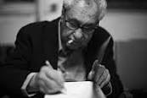
Elliott Erwitt is an advertising and documentary photographer known for his black and white candid shots of ironic and absurd situations within everyday settings— a master of Henri Cartier-Bresson's "decisive moment

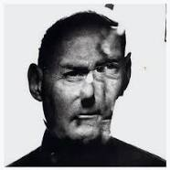
Irving Penn was an American photographer known for his fashion photography, portraits, and still lifes. Penn's career included work at Vogue magazine, and independent advertising work for clients including Issey Miyake, and Clinique

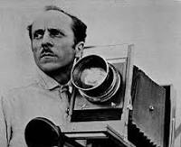

Edward Henry Weston was a 20th-century American photographer. He has been called "one of the most innovative and influential American photographers…" and "one of the masters of 20th century photography.

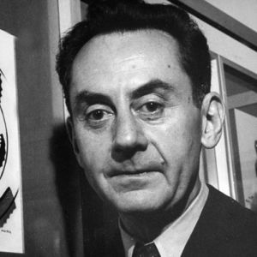

Man Ray (born Emmanuel Radnitzky, August 27, 1890 – November 18, 1976) was an American visual artist who spent most of his career in France. He was a significant contributor to the Dada and Surrealist movements, although his ties to each were informal. He produced major works in a variety of media but considered himself a painter above all. He was best known for his photography, and he was a renowned fashion and portrait photographer. Man Ray is also noted for his work with photograms, which he called "rayographs" in reference to himself.

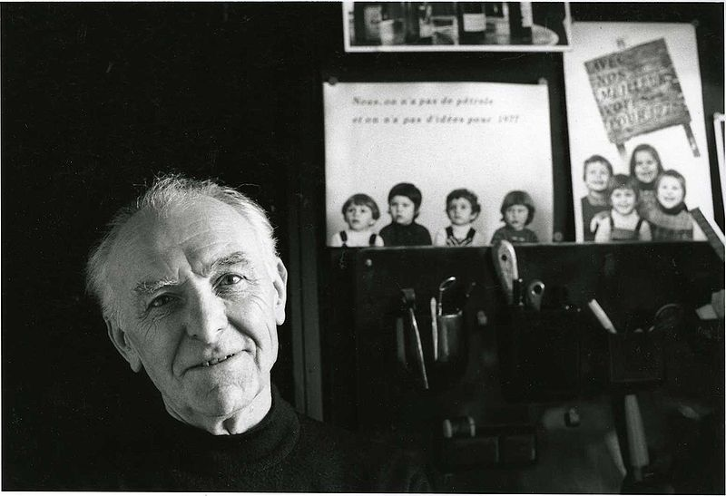
Robert Doisneau 14 April 1912 – 1 April 1994) was a French photographer. In the 1930s he used aLeica on the streets of Paris. He and Henri Cartier-Bresson were pioneers of photojournalism. He is renowned for his 1950 image Le baiser de l'hôtel de ville (Kiss by the Town Hall), a photograph of a couple kissing in the busy streets of Paris. Doisneau was appointed a Chevalier (Knight) of the Legion of Honour in 1984.

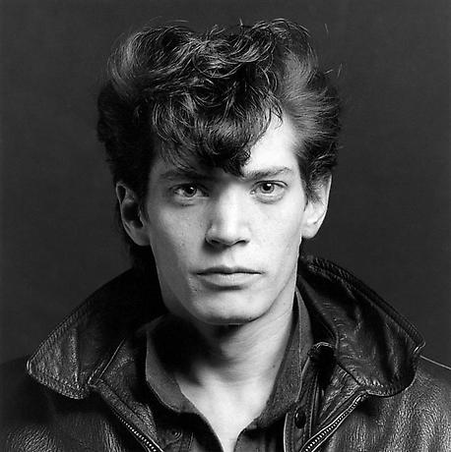

Robert Mapplethorpe (/ˈmeɪpəlˌθɔrp/; November 4, 1946 – March 9, 1989) was an American photographer, known for his sometimes controversial large-scale, highly stylized black and white photography. His work featured an array of subjects, including celebrity portraits, male and female nudes, self-portraits and still-life images of flowers. His most controversial work is that of theunderground bondage and sadomasochistic BDSM scene in the late 1960s and early 1970s of New York. The homoeroticism of this work fuelled a national debate over the public funding of controversial artwork.

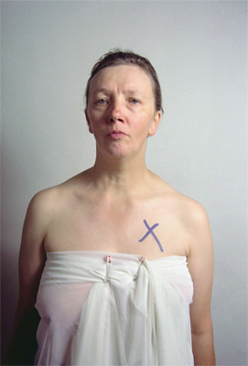

Jo Spence (15 June 1934, London – May 1992) was a British photographer. She began her career in the field of commercial photography but soon started her own agency which specialised in family portraits, and wedding photos.^{[1]} In the 1970s, she refocused her work towards documentary photography.^{[2]} Many of her works were self-portraits about her own fight with breast cancer.^{[1]} During her prolific photography practice, she became known for her politicised approach to her art form, with socialist and feminist themes throughout her career

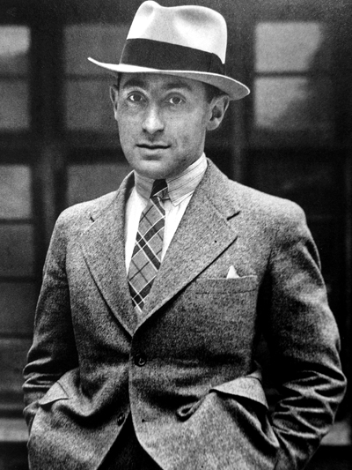
Alfred Eisenstaedt (December 6, 1898 – August 23, 1995) was a German-born American photographer and photojournalist. One of the most prolific photographers of the twentieth century, he began his career in pre-World War II Germany, and after moving to the U.S., achieved prominence as a staff photographer for Life Magazine which featured more than 90 of his pictures on its covers with over 2,500 photo stories published.
Among his most famous cover photographs was the V-J Day celebration in New York City of "an exuberant American sailor kissing a nurse in a dancelike dip [that] summed up the euphoria many Americans felt as the war came to a close."^{[1]} Eisenstaedt was "renowned for his ability to capture memorable images of important people in the news, including statesmen, movie stars and artists" and for his candid photographs, taken with a small 35mm Leica camera and typically with only natural lighting.

